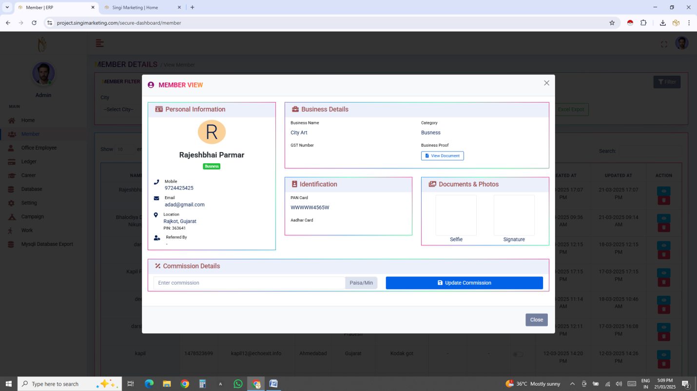

Commison ni baju ma target nu option mukvu

Target Farjiyat no rakhvo option ma rakhvo jo target nakhi to j cansidar karvo Target = refral karel member nu volet balance cansidar karvu

Ex. 50000 badha refra madi ne target ganvo

Catagry & Sub Catagry & City Show karvi

Name ni upar logo ma client no photo show karvo round ma

Web Changes

Menu

1) Home

2) Members Corner

3) Services

4) Terms & Conditions

5) Privacy policy

6) Contact us

7) About us

8) Downloads

More services = SERVICES PAGE open

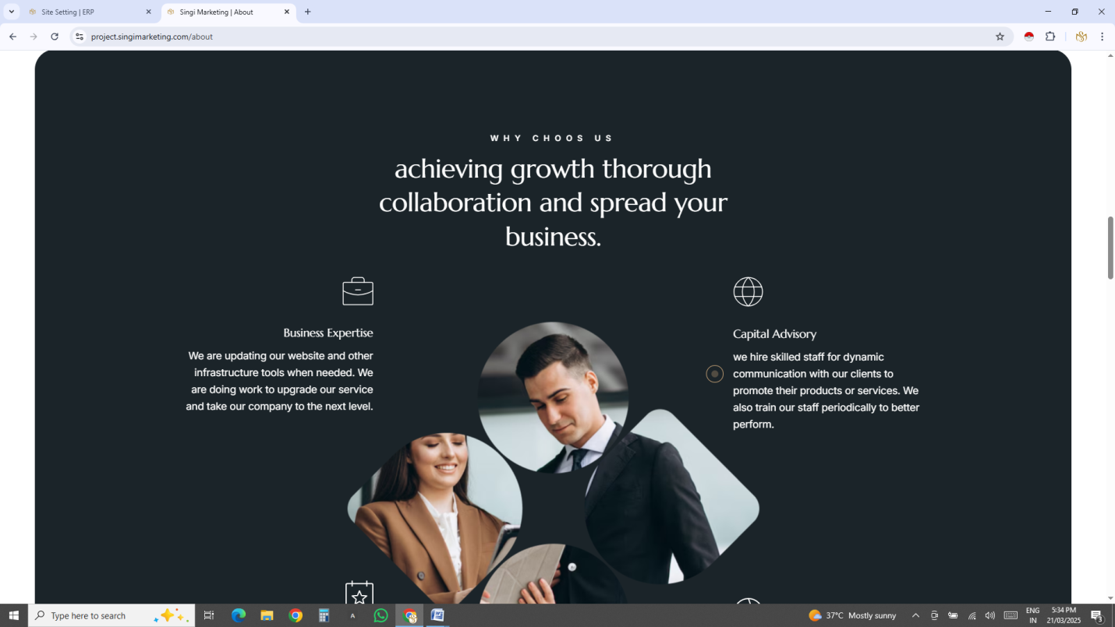

Aa page ma title baki che

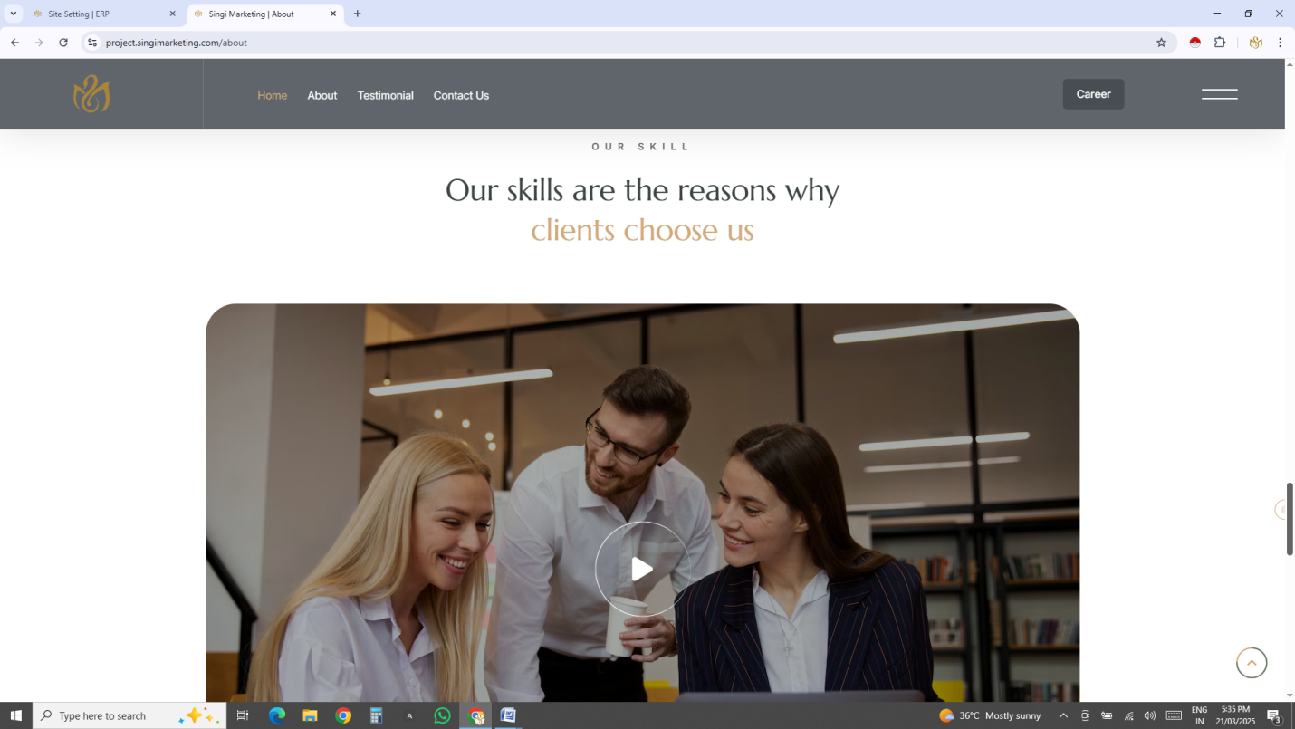

Aa page che

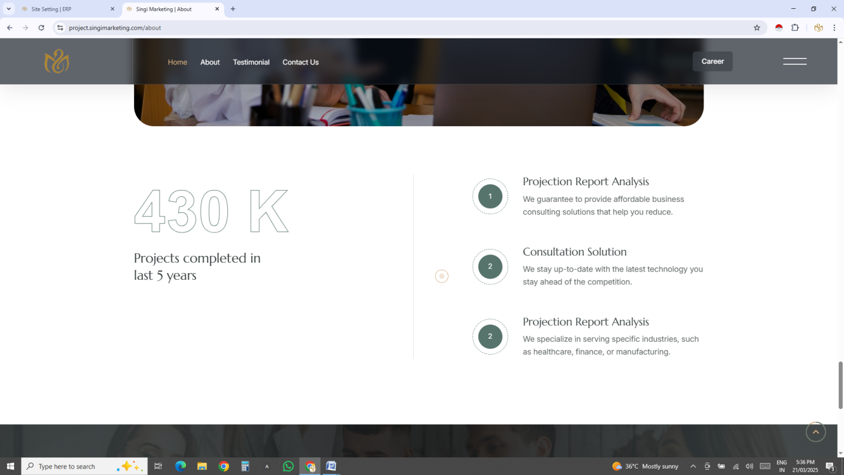

Aa page baki

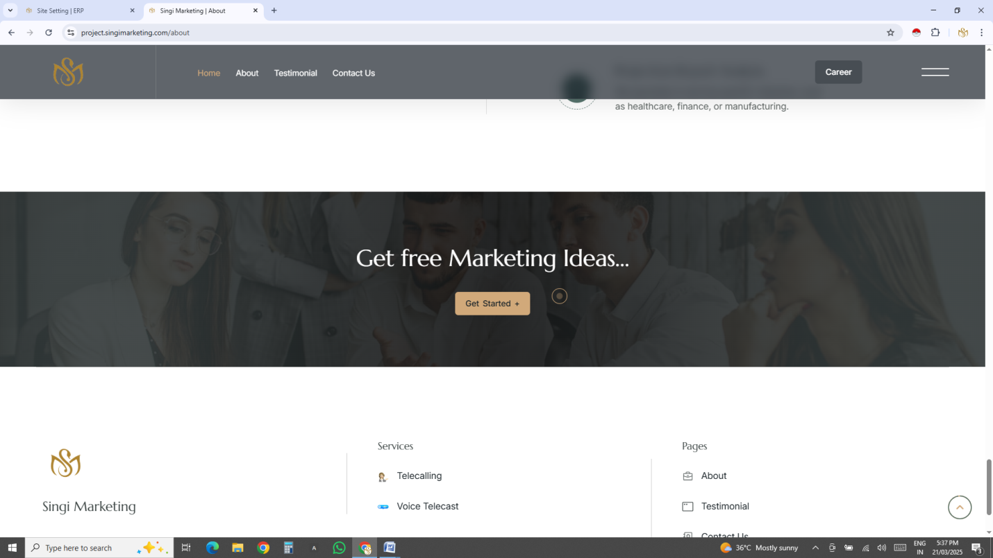Grt Free Marketing Ideas & Bennar Vadu baki

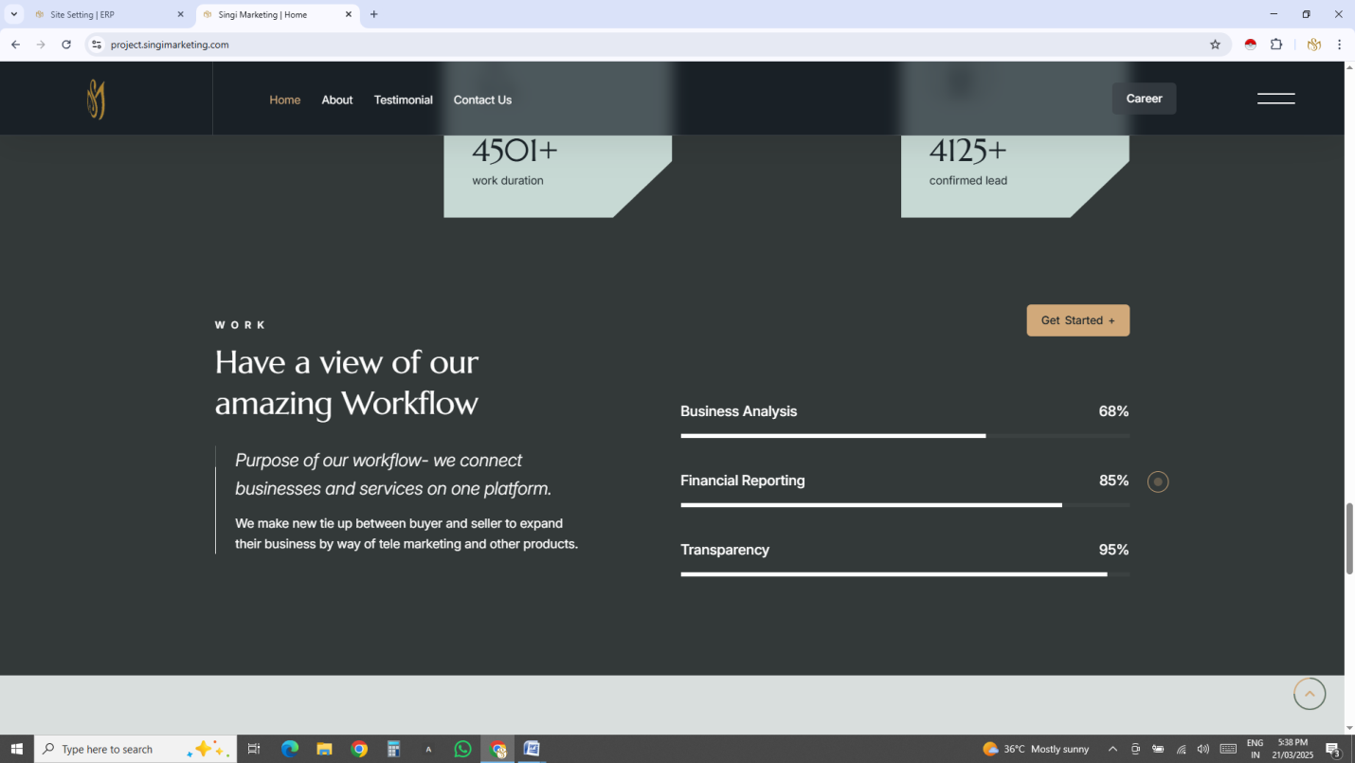aa baki che % vadu

accuracy= total call /success lead \*100 = %

Business develop= use balance/Sucsess lead = 7 %

Ex.1000/15=66.67 X 100 / 1000 = 6.67 %(7% Round)

cost efficiency= 99 % (Fix)

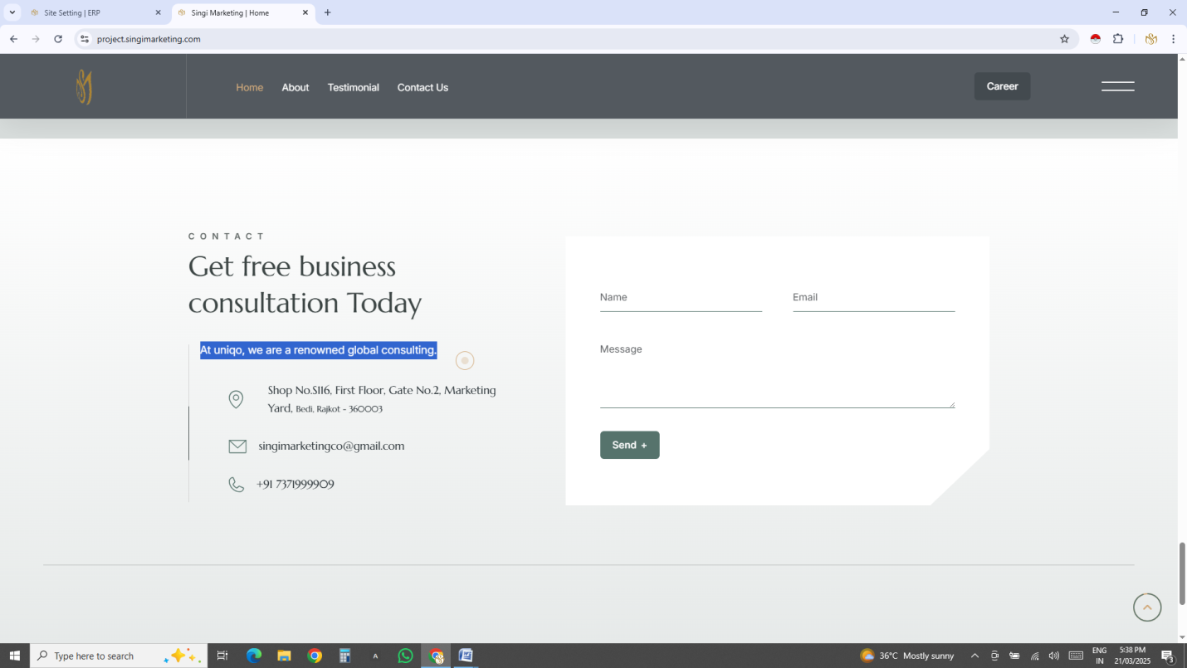

At uniqo, we are a renowned global consulting. = Sole Combination of Quirky Ideas On One Platform.

Get free business consultation Today = Singi Marketing

Msg box title = Write to us

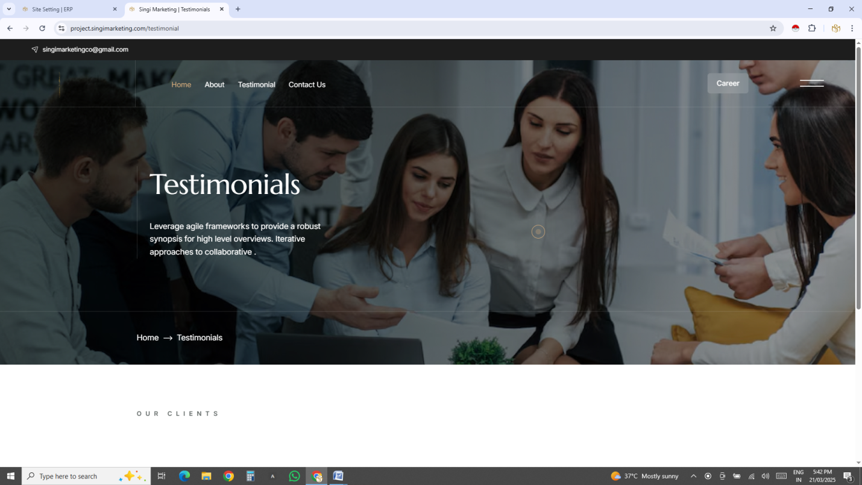

Testimonial page bak

Testimonial change name Members Corner

Video banner

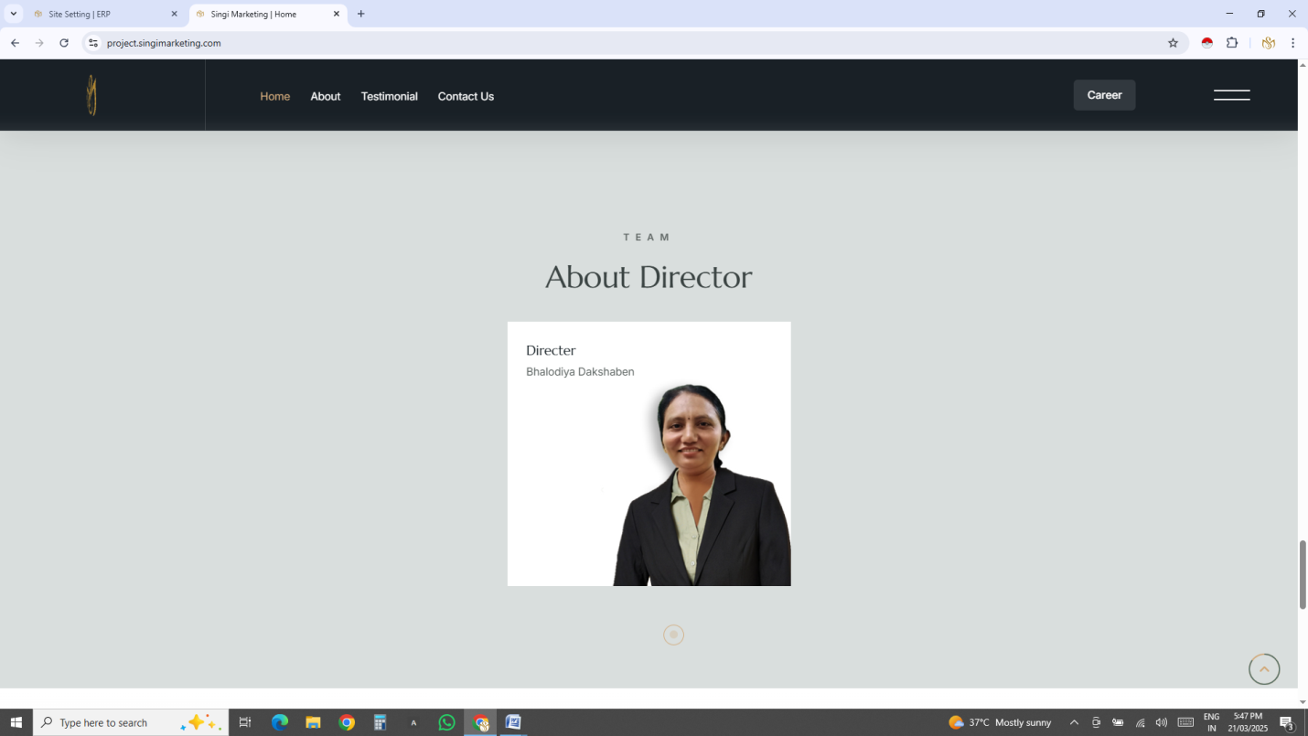

Team ma ditels nu box mukvu

Service page banavavanu baki che te banavavu